Resume Management System: Resumanager

Regis University

Software Practicum I

Professor: Dr Kevin Pyatt

Resumanager

Edited By

Vishal Kaushik

**Abstract**

I have several years of work experience and have created resume many times during my search of internship, and full-time jobs. Every time I create or want to update a resume, I have to find out where it was saved and then modify based on the current requirement. Sometimes, it is required to keep different versions of resume for different employers, thus several files must be saved in the hard drive for future needs. That makes the management cumbersome. I always wanted to make an application that can help make this job easier and keep all my resumes at one place without worrying about maintenance. I also experienced that many times my resume did not get noticed because I was not very proficient in resume writing, that resulted in many missed opportunities. This class is a very strong platform to come up with an application that can do the job efficiently and that is where the “Resumanager” comes to the rescue.

Resumanager is an application that allows groups of students, professionals and even a beginner with no experience in writing professional resumes to connect with recruiters, headhunters and companies. This not only allows them to showcase their skills via a well formatted, professionally written profiles, but also get noticed in this competitive world and land their dream job or internship.

This application will allow users to input their information including educational background, current and previous work experiences, skills, certifications, professional degrees/diplomas, hobbies as well as personal information like contact details, email, address, and any other relevant details in a structured way.

Also, it will allow users to print the resume in different formats in a word document and also save it in the database at the same time, so that they can retrieve it later and make any necessary changes easily without the need of writing or creating the resume from scratch. With this application users can create multiple resumes targeting different potential employers and save the resumes in the database for later retrieval.

The Resumanager application will help individuals to manage the resume at a single place that can be accessed just with a click of a button.

**Design Goals**

As the application is built for ease of use and maintenance of resume making tasks, it will be designed for the following goals:

* **Improved efficiency:** The features will be focused on enabling users to perform tasks with a level of productivity as it saves them time and hassle, which wasn't possible without such tools.
* **Versatility:** The users can perform a wide variety of tasks effectively in a variety of circumstances with a complete, fine-grained control over their work.
* **Scalability:** The application will be designed to help scale as per user’s requirement without impacting the initial design and ease of maintenance.
* **Eliminate redundancy:** The application will be designed to remove redundant steps.

**Envisioned Architecture**

The Resumanager application will be a Desktop based 2 TIER application: application client and the database layer. The application GUI will be designed in QT 5.3 framework (an opensource, cross-platform framework for GUI), the backend code will be C++11 and the database used will be MySQL database.  
The architecture of the application is show in below picture.

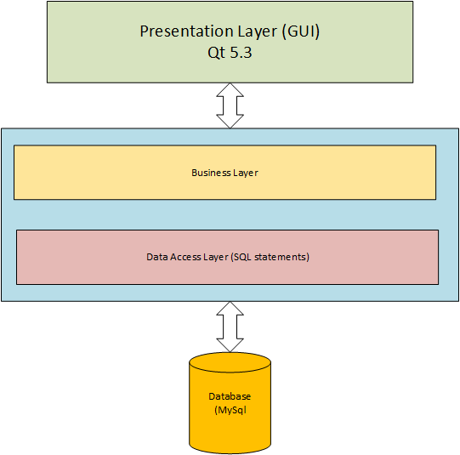

**Common Good Computing Considerations**

The Resumanager application is designed to automate the resume building and management. The application will be designed keeping in mind the requirements and simplicity of use to get the desired results fast. The application must cater basic needs and help individuals to write professional resumes and target potential employers.

**Future Goals**

* The Resumanager application will be extended to be used by recruiters or headhunters as a resume database, where they can see the resume inventory of different skill sets and will be able to communicate with individuals by showing interest in their resumes or can contact them directly through phone or email.
* The application can be extended from a Desktop based application to a web based tool as a future development plan .